Experiment – 7: Continuous-Time Fourier Transform and Spectrum
ii) To determine the magnitude and phase spectra of continuous-time signals and analyze their significant spectral components
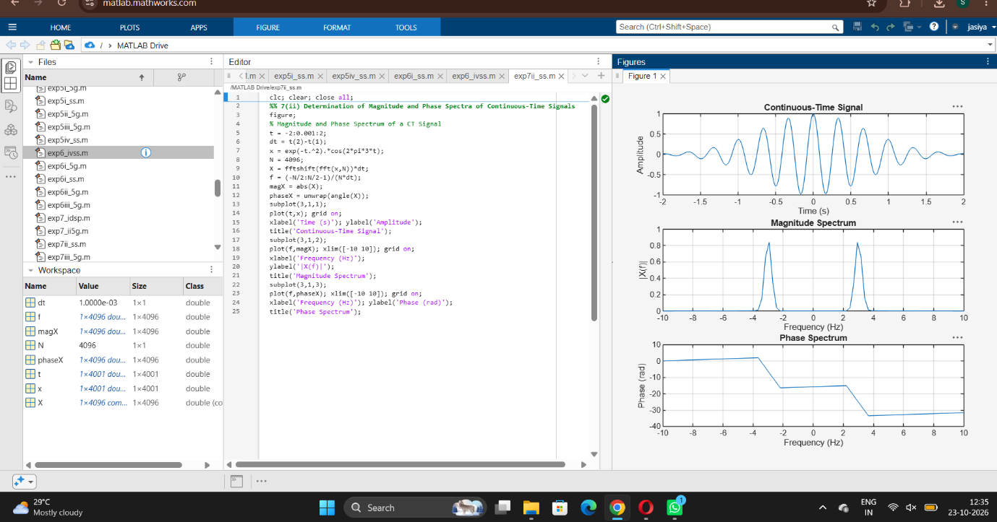
iii) Verification of Fourier Transform Properties and Frequency-Domain Characteristics
